

Team Formation and Project Preliminary

Campus Wellness Portal with Medical System and Fitness Center Integration

Version: 1.0

Date: 23/05/2025

Release By: TT6L - Group 3**Table of Content**

**1. Project Vision 3**

1.1 Project Title 3

1.2 Background and Rationale 3

1.3 Vision Statement 3

1.4 System Objectives 3

1.5 Value Proposition 4

**2. Scope 4**

**3. Goals 5**

**4. Team Formation 5**

4.1 Github Repository 5

4.2 Discussions 6

## 

## **1. Project Vision**

### **1.1 Project Title**

**Campus Wellness Portal with Medical System and Fitness Center Integration**

### **1.2 Background and Rationale**

University life often places immense pressure on students, impacting their physical, mental and emotional well-being. While institutions offer health and recreational services, accessing these services is frequently fragmented, inefficient or underutilized. As a result, students often struggle with scheduling appointments, finding time for fitness activities and managing wellness goals due to the lack of an integrated system.

The Campus Wellness Portal is envisioned as a unified, student-centered platform designed to enhance the accessibility, coordination and personalization of campus wellness services. By integrating the university’s existing Health Center Appointment System and Campus Fitness/Recreation Center Management Software, the platform will create a centralized ecosystem where students can proactively manage their health and wellness activities.

### **1.3 Vision Statement**

The Campus Wellness Portal aims to empower students to take charge of their holistic well-being by providing a seamless digital platform that facilitates access to medical services, fitness programs and personalized wellness tracking tools — all in one integrated and user-friendly system.

### **1.4 System Objectives**

* To provide a centralized portal for booking and managing health center appointments.
* To facilitate fitness class bookings and gym reservations through an integrated schedule interface.
* To allow students to set and monitor personalized wellness goals (e.g., sleep, exercise, hydration).
* To deliver real-time notifications and reminders for appointments, bookings, and goal tracking.
* To improve engagement and usage of campus wellness services by offering an intuitive, digital-first experience.
* To ensure secure and role-based access for students and staff using university authentication systems.

### **1.5 Value Proposition**

By combining wellness services into a single, cohesive platform, the Campus Wellness Portal will:

* Reduce administrative overhead for health and fitness staff.
* Encourage proactive wellness habits among students.
* Increase student satisfaction with campus services.
* Enable data-driven insights for service optimization and student wellness trends.

## **2. Scope**

The system will encompass the following key features:

* Allow real-time scheduling and management of medical sessions appointments.
* Allow real-time scheduling and management of fitness classes appointments.
* Allow real-time booking and management of gym facilities.
* Monitor student’s health and suggest required actions to keep students healthy.
* Provide notification alerts to remind students of schedule’s activity.
* Allow role-based control on accessibility of system functionalities.
* Ensure user’s data privacy by using necessary encryptions.

## 

## **3. Goals**

The system is designed with the following objectives:

* Promoting overall student wellness, combined with rising concerns over mental and physical health in academic settings.
* Allow easy access to campus health and fitness services for all students.
* Ease scheduling management of medical appointments and fitness classes.
* Ease administrative control by simplifying system diagnostic and user role management.
* Provide conveniency between students, doctors and fitness instructors through timely notifications and updates.
* Ensure data privacy and security in accordance with university policies and health data regulations.
* Support student well-being holistically by combining physical health, fitness, and emotional support in one integrated system.

## **4. Team Formation**

### **4.1 Team Members**

| Name | Student ID | Email | Phone Number |
| --- | --- | --- | --- |
| Lee Xiang Ze | 1211106818 | 1211106818@student.mmu.edu.my | 011-63388308 |
| Yeoh Han Yi | 1211106319 | 1211106319@student.mmu.edu.my | 012-5568050 |
| Yu Ting Hui | 241UC240ZD | yu.ting.hui@student.mmu.edu.my | 019-4753528 |
| Ng Jin Mun | 241UC240BF | ng.jin.mun@student.mmu.edu.my | 018-3782959 |

### 

### **4.2 Github Repository**

<https://github.com/TheINSANE333/TT6L_G3_Requirements_Project>

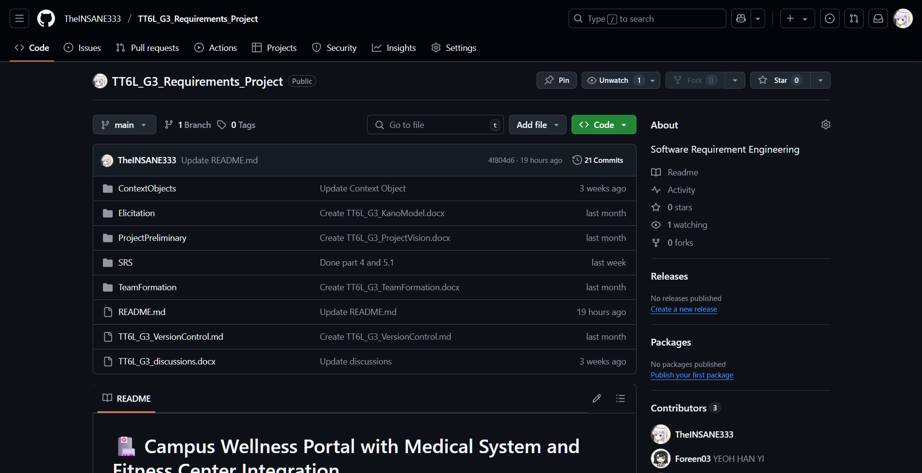

*Figure 4.1 Github repository*

**4.3 Discussions**

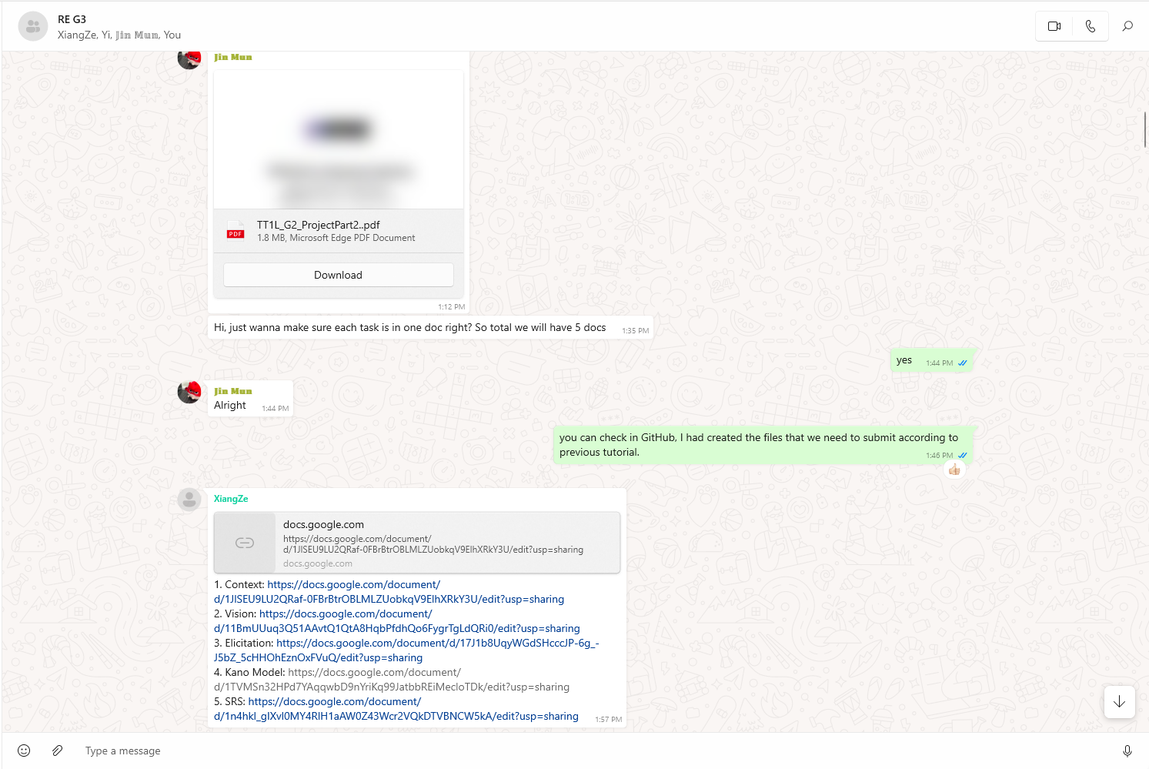

*Figure 4.2 Discussion on github’s file path management*

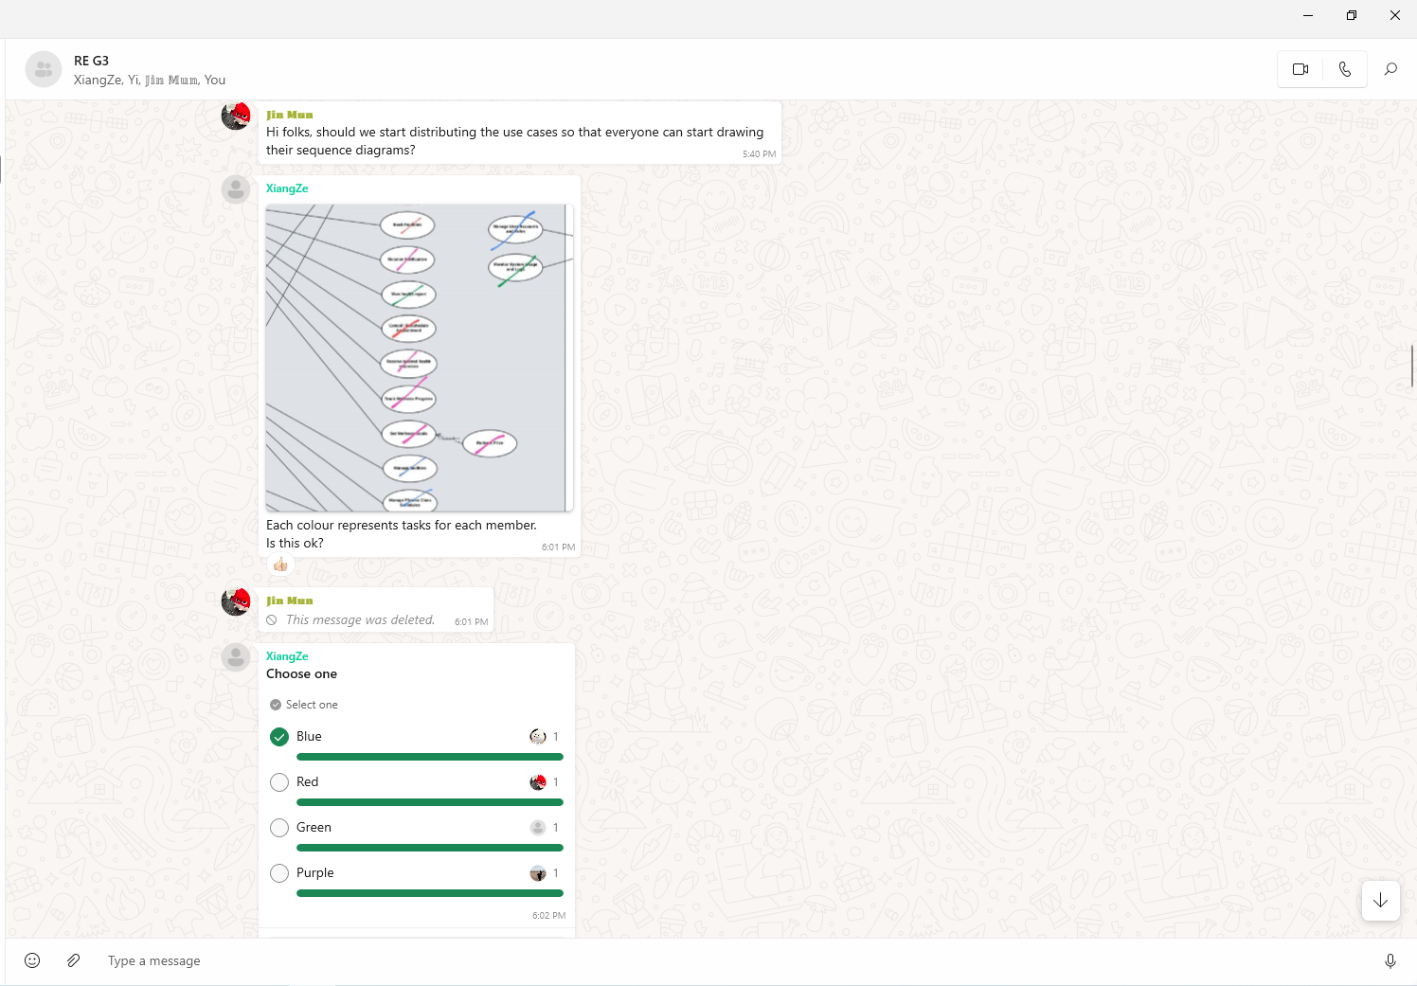

*Figure 4.3 Task distribution on drawing use case diagram*

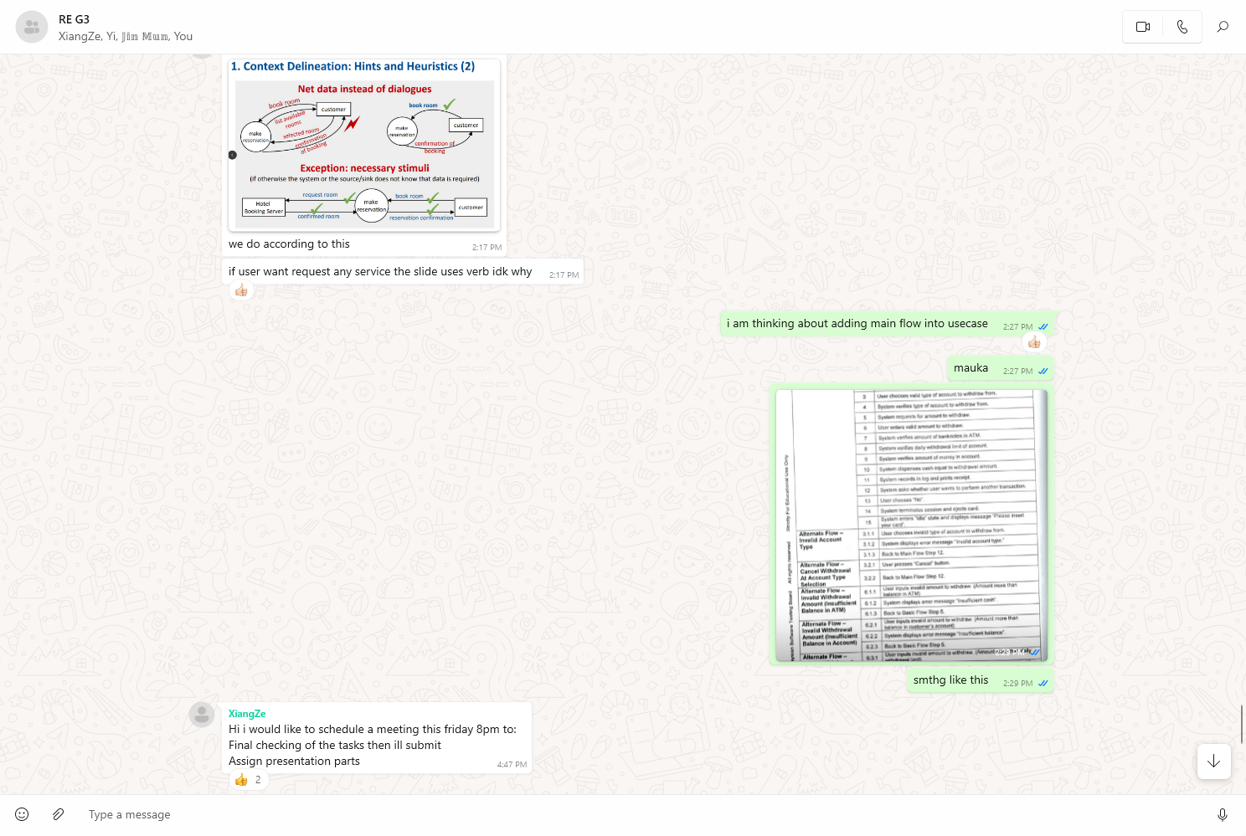

*Figure 4.4 Discussion on adding details in use case table*

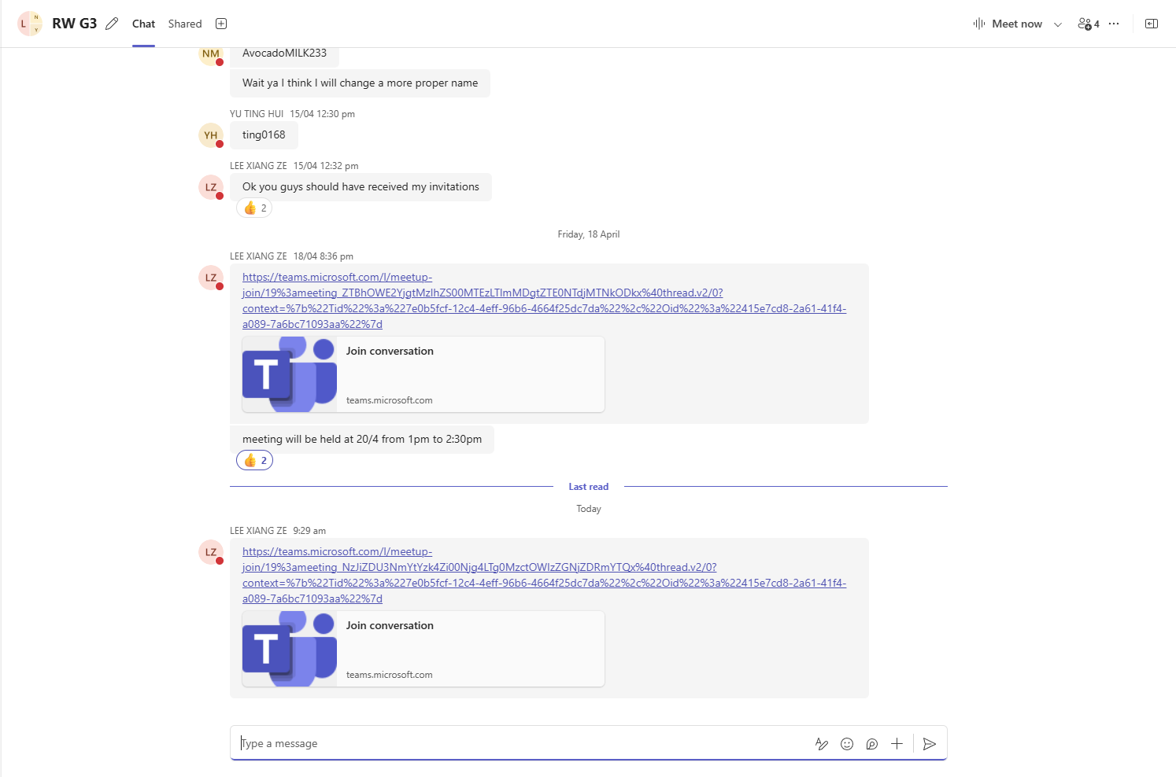

*Figure 4.5 Scheduling meeting in teams*

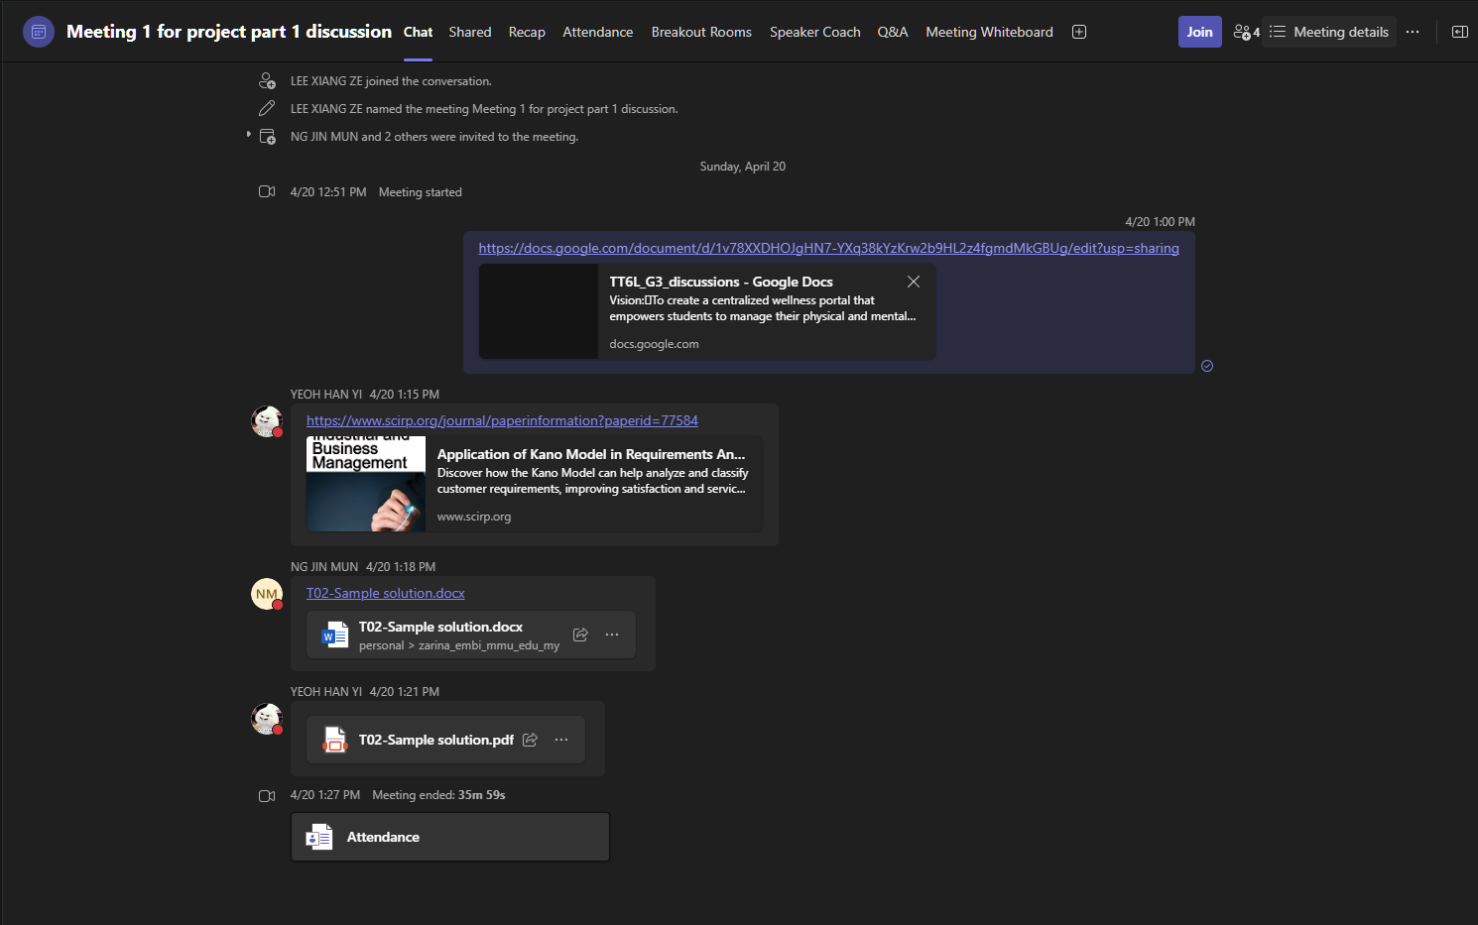

*Figure 4.6 Meeting 1’s chat*

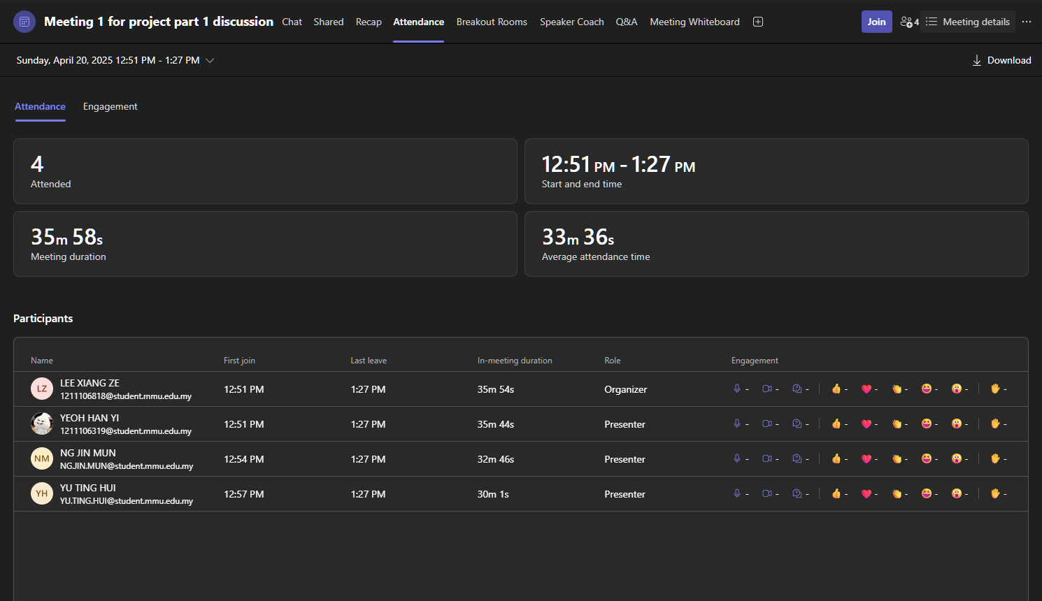

*Figure 4.7 Meeting 1’s attendance*

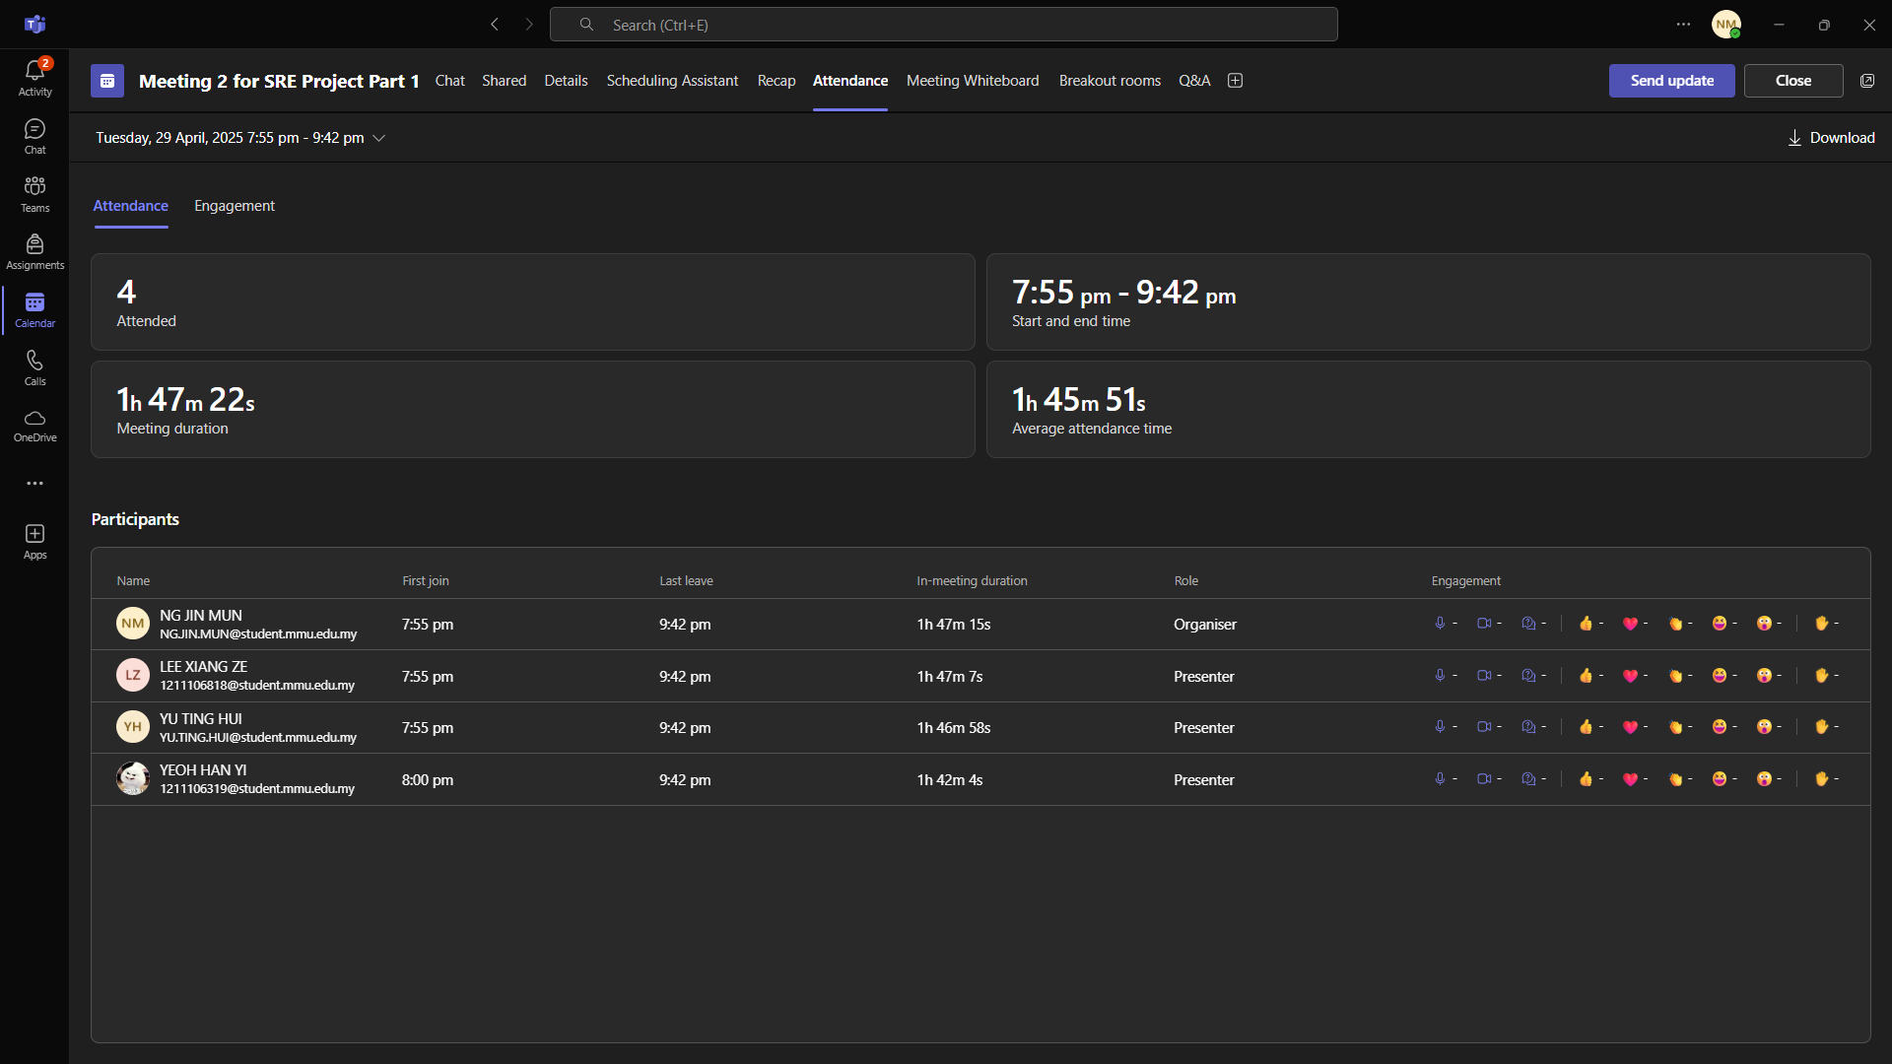

*Figure 4.8 Meeting 2’s attendance*

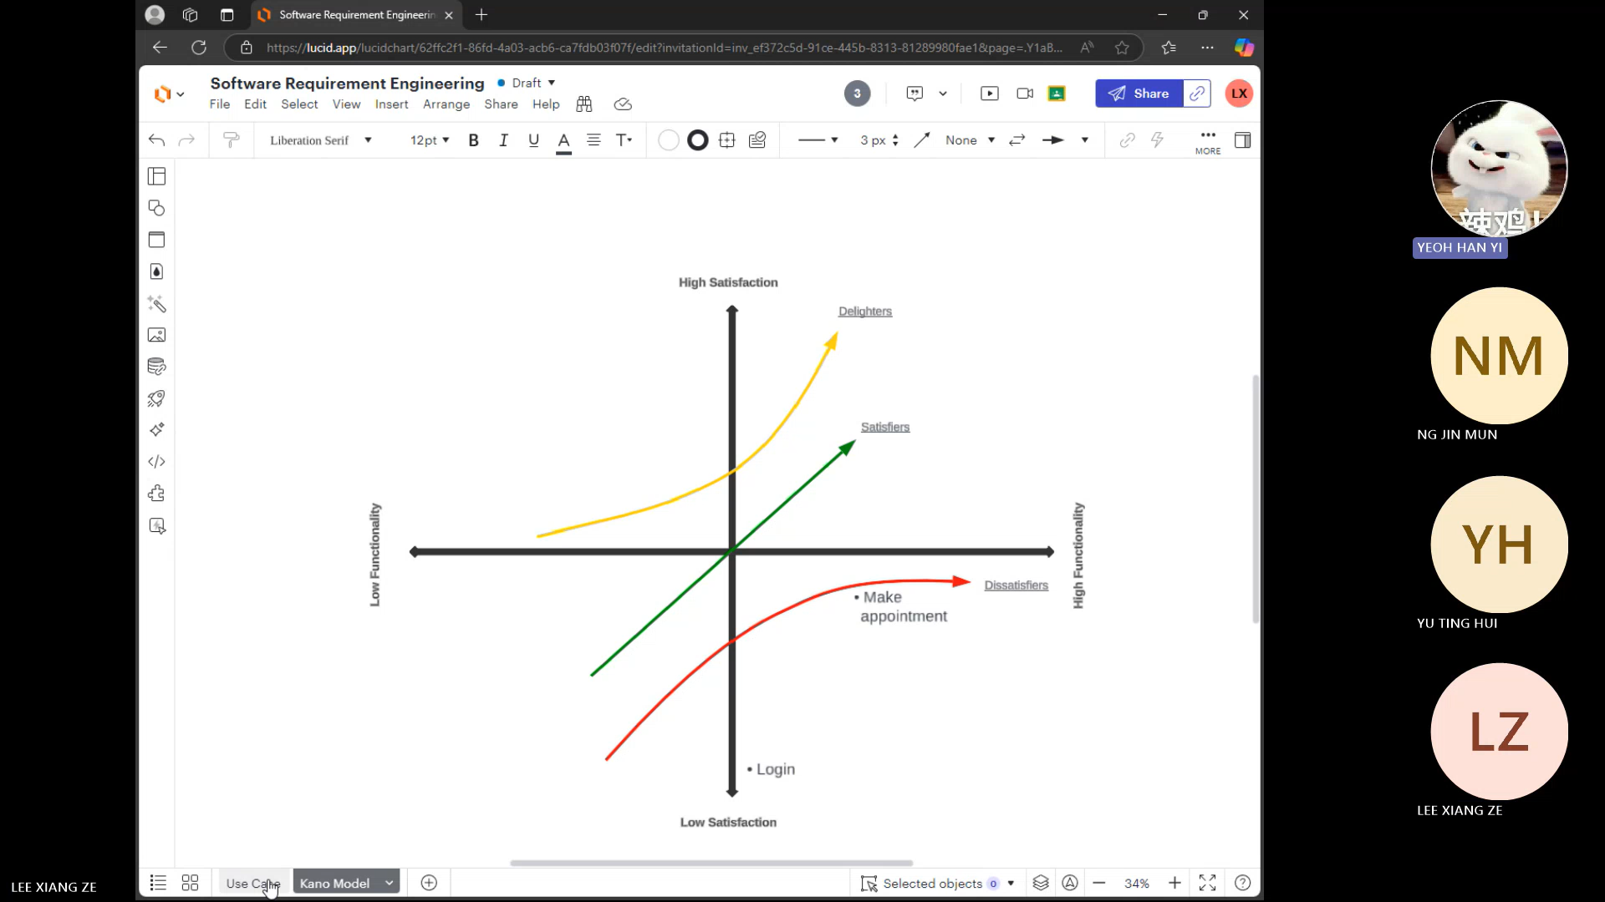

*Figure 4.9 Meeting 2’s Discussion on how to draw a Kano Model*

Below is the link of recording for our meeting 2:

[Recap: Meeting 2 for SRE Project Part 1 Tuesday, 29 April](https://teams.microsoft.com/l/meetingrecap?driveId=b%21uA3ock664EigZAz7spXQQkB3wwZxBhdNvTdZdP_c4JlZcIIe3dnTSbNzKVpSZppB&driveItemId=01IIE4OSFKRKAJKF3M2FDYH5LJO3R3LGPZ&sitePath=https%3A%2F%2Fmmuedumy-my.sharepoint.com%2F%3Av%3A%2Fg%2Fpersonal%2Fng_jin_mun_student_mmu_edu_my%2FEaqKgJUXbNFHg_VpduO1mfkBAy7l3ptuSGIM-Gyfk5vYZQ&fileUrl=https%3A%2F%2Fmmuedumy-my.sharepoint.com%2Fpersonal%2Fng_jin_mun_student_mmu_edu_my%2FDocuments%2FRecordings%2FMeeting%25202%2520for%2520SRE%2520Project%2520Part%25201-20250429_200258-Meeting%2520Recording.mp4%3Fweb%3D1&iCalUid=040000008200e00074c5b7101a82e00800000000b4a4c84dccb8db010000000000000000100000001ebe461c29c053439e176d67e367b68d&threadId=19%3Ameeting_MWMxMmQ3ODktNTQ0ZS00NTIzLTkwYWItOGJlYzFlZDZjNzJm%40thread.v2&organizerId=49f8112a-4f7e-4620-9782-713819f9f993&tenantId=7e0b5fcf-12c4-4eff-96b6-4664f25dc7da&callId=f0c89d5c-f00a-4e22-b93d-f4175d8baacf&threadType=Meeting&meetingType=Scheduled&subType=RecapSharingLink_RecapCore)

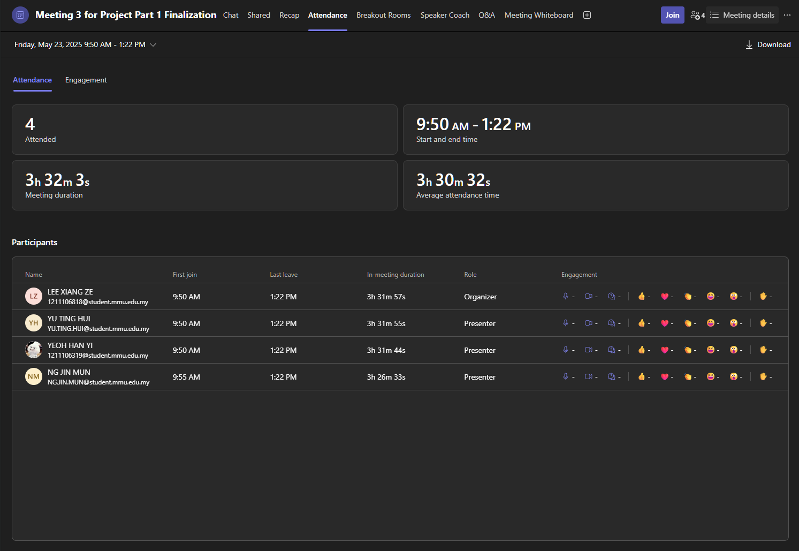

*Figure 4.10 Meeting 3’s attendance*

Below is the link of recording for our meeting 3:

[Recap: Microsoft Teams meeting Friday, May 23](https://teams.microsoft.com/l/meetingrecap?driveId=b%21NePVrzWmHE6mCJZUX_3wN2G-MGMUyOxCjwO1Vro4AAmTDO7TpaxxR5H9BRCotQY2&driveItemId=01XYYXGY2HE3NLKSQ4NFB2BAHEIJF67L4W&sitePath=https%3A%2F%2Fmmuedumy-my.sharepoint.com%2F%3Av%3A%2Fg%2Fpersonal%2F1211106818_student_mmu_edu_my%2FEUcm2rVKHGlDoIDkQkvvr5YBIBMo4e3nLHEJUyb_N2kcgg&fileUrl=https%3A%2F%2Fmmuedumy-my.sharepoint.com%2Fpersonal%2F1211106818_student_mmu_edu_my%2FDocuments%2FRecordings%2FMicrosoft%2520Teams%2520meeting-20250523_095556-Meeting%2520Recording.mp4%3Fweb%3D1&iCalUid=040000008200e00074c5b7101a82e008000000001392290082cbdb010000000000000000100000009cff493b5c61d44f9659a3759700c5b0&threadId=19%3Ameeting_NzJiZDU3NmYtYzk4Zi00Njg4LTg0MzctOWIzZGNjZDRmYTQx%40thread.v2&organizerId=415e7cd8-2a61-41f4-a089-7a6bc71093aa&tenantId=7e0b5fcf-12c4-4eff-96b6-4664f25dc7da&callId=8a0abd2b-91bc-4781-a626-3dbab40ed197&threadType=Meeting&meetingType=Scheduled&subType=RecapSharingLink_RecapCore)